Day 21 - 26th July- 113195064 - Bondili Bhavya Charitha

Tasks Explanation done by mehar ✅
Plz work on Doc 07 in docs to study folder – Done ✅
Dependency - It is temporary - Borrowing my neighbor’s air frier .
Aggregation - Independent it is - if you delete a playlist, it doesn't delete the songs.
Composition - Dependent - I bought a box of chocolates. once the box gone, chocolates also gone .

Task:1 - Can you create a code based on the below diagrammatic representation.
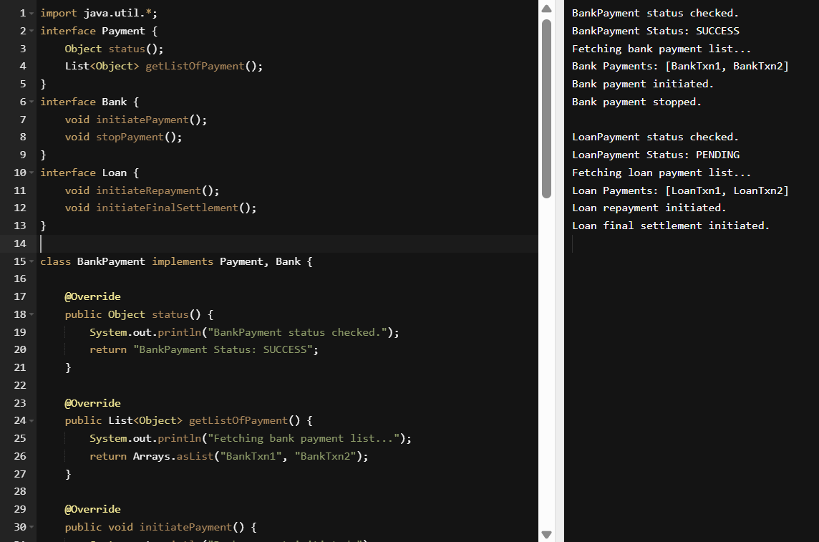
import java.util.*;
interface Payment {
Object status();
List<Object> getListOfPayment();
}
interface Bank {
void initiatePayment();
void stopPayment();
}
interface Loan {
void initiateRepayment();
void initiateFinalSettlement();
}

class BankPayment implements Payment, Bank {

@Override
public Object status() {
System.out.println("BankPayment status checked.");
return "BankPayment Status: SUCCESS";
}

@Override
public List<Object> getListOfPayment() {
System.out.println("Fetching bank payment list...");
return Arrays.asList("BankTxn1", "BankTxn2");
}

@Override
public void initiatePayment() {
System.out.println("Bank payment initiated.");
}

@Override
public void stopPayment() {
System.out.println("Bank payment stopped.");
}
}

class LoanPayment implements Payment, Loan {

@Override
public Object status() {
System.out.println("LoanPayment status checked.");
return "LoanPayment Status: PENDING";
}

@Override
public List<Object> getListOfPayment() {
System.out.println("Fetching loan payment list...");
return Arrays.asList("LoanTxn1", "LoanTxn2");
}

@Override
public void initiateRepayment() {
System.out.println("Loan repayment initiated.");
}

@Override
public void initiateFinalSettlement() {
System.out.println("Loan final settlement initiated.");
}
}

public class Main {
public static void main(String[] args) {
Payment bank = new BankPayment();
System.out.println(bank.status());
System.out.println("Bank Payments: " + bank.getListOfPayment());

Bank bankOps = (Bank) bank;
bankOps.initiatePayment();
bankOps.stopPayment();

System.out.println();

Payment loan = new LoanPayment();
System.out.println(loan.status());
System.out.println("Loan Payments: " + loan.getListOfPayment());

Loan loanOps = (Loan) loan;
loanOps.initiateRepayment();
loanOps.initiateFinalSettlement();
}
}

TASK:2 –
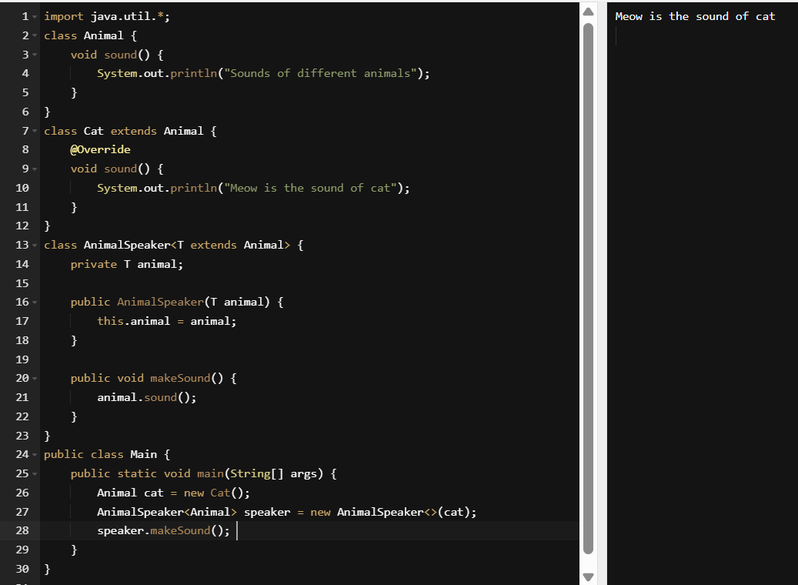

TASK: 3 to TASK: 12 Reference Done ✅ - Few Codes explained by mehar.

